E³Point product submittal
Toxic and Combustible Gas Detector
Standalone Platform (Single or Dual-Gas Monitoring)
Ordering Information
Single-Gas Configuration: Base Unit, Surface-Mount
* Base unit and sensor cartridge sold together ** Base unit only; sensor cartridge sold separately
Part Number Description
□ E3SASCO* E³Point, CO sensor cartridge, Surface-mount, 24Vac/dc, -20 to 50ºC (-4 to 122ºF)
□ E3SA** E³Point, Surface-mount, 4-20mA, 24Vac/dc, -40 to 50ºC (-40 to 122ºF)
□ E3SAHSCO* E³Point, CO sensor cartridge, Surface-mount, 120Vac, -20 to 50ºC (-4 to 122ºF)
□ E3SAH** E³Point, Surface-mount, 4-20mA, 120Vac, -40 to 50ºC (-40 to 122ºF)
Dual-Gas Configuration: Base Unit w/Remote Sensor Capability, Surface-Mount
Part Number Description
□ E3SARSCO* E³Point, CO sensor cartridge, Surface-mount, 24Vac/dc, Dual-mode, -20 to 50ºC (-4 to 122ºF)
□ E3SAR** E³Point, Surface-mount, 4-20mA, 24Vac/dc, Dual-mode, -40 to 50ºC (-40 to 122ºF)
□ E3SARHSCO* E³Point, CO sensor cartridge, Surface-mount, 120Vac, Dual-mode, -20 to 50ºC (-4 to 122ºF)
□ E3SARH** E³Point, Surface-mount, 4-20mA, 120Vac, Dual-mode, -40 to 50ºC (-40 to 122ºF)
Remote Sensors (always sold with sensor cartridge included)
Part Number Description
□ E3SRMCO E³Point, Remote Sensor, -20 to 50ºC (-4 to 122ºF), Carbon Monoxide
□ E3SRMNO2 E³Point, Remote Sensor, -20 to 50ºC (-4 to 122ºF), Nitrogen Dioxide
□ E3SRMH2S E³Point, Remote Sensor, -20 to 50ºC (-4 to 122ºF), Hydrogen Sulfide
□ E3SRMH2 E³Point, Remote Sensor, -20 to 50ºC (-4 to 122ºF), Hydrogen
□ E3SRMO2 E³Point, Remote Sensor, -20 to 50ºC (-4 to 122ºF), Oxygen
□ E3SRMM E³Point, Remote Sensor, -20 to 50ºC (-4 to 122ºF), Methane
□ E3SRMP E³Point, Remote Sensor, -20 to 50ºC (-4 to 122ºF), Propane
Stand-Alone Platform, Duct-Mount
Part Number Description
□ E3DASCO* E³Point, CO, Duct-mount, 24Vac/dc, -20 to 50ºC (-4 to 122ºF)
□ E3DA** E³Point, Duct-mount, 4-20mA, 24Vac/dc, -40 to 50ºC (-40 to 122ºF)
Sensor Cartridges
Part Number Description
□ E3SCO CO Cartridge -20 to 50ºC (-4 to 122ºF), Carbon Monoxide
□ E3NO2 NO₂ Cartridge -40 to 50ºC (-40 to 122ºF), Nitrogen Dioxide
□ E3H2S H₂S Cartridge -40 to 50ºC (-40 to 122ºF), Hydrogen Sulfide
□ E3H2 H₂ Cartridge -40 to 50ºC (-40 to 122ºF), Hydrogen
□ E302 O₂ Cartridge -40 to 50ºC (-40 to 122ºF), Oxygen
□ E3M CH₄ Cartridge -40 to 50ºC (-40 to 122ºF), Methane
□ E3P C₃H₈ Cartridge -40 to 50ºC (-40 to 122ºF), Propane
Examples of How to Order
To order a stand-alone version, surface-mount, analog, CO detector, -20 to 50ºC (-4 to 122ºF): Order E3SASCO
To order a stand-alone version, surface-mount, analog, dual-gas CO + NO₂, -20 to 50ºC (-4 to 122ºF): Order E3SARSCO + E3SRMNO2
To order a stand-alone version, duct-mount, analog, propane detector, -40 to 50ºC (-40 to 122ºF): Order E3DA + E3P
To order a stand-alone version, surface-mount, analog, dual-gas CO + C₃H₈, 120Vac, -20 to 50ºC (-4 to 122ºF): Order E3SARHSCO + E3SRMP

specifications
General Specifications
Uses
Wall or duct-mounted gas detector for monitoring carbon monoxide (CO), nitrogen dioxide (NO₂), oxygen (O₂), methane (CH₄), hydrogen (H₂), hydrogen sulphide (H₂S), and propane (C₃H₈), installed as a standalone device with single-gas or dual-gas monitoring. (Note: E³Point standalone version replaces Vulcain models VA201T, VA201M and VA301M)
Size 20.56 x 14.90 x 6.72cm (8.09 x 5.87 x 2.65”) (H x W x D); Remote Sensor: 3.5 x 4.5 x 6.5 cm (1.36 x 1.75 x 2.56”)
Power Requirement 24 Vac nominal (17-27Vac), 50/60 Hz, 0.4A; 24Vdc nominal (20-38Vdc); with remote sensor: 7 W max.
Optional Main AC Input 120Vac nominal, +/- 10% (with on-board transformer)
Relay Output 2 DPDT relays, 5A @ 250Vac; 5A @ 30Vdc
Communications 4-20mA
Operating Environment Commercial, Indoor, Extreme Temperature Environments
Operating Temperature H₂S, NO₂, O₂, CH₄, H₂, C₃H₈: -40 to 50ºC (-40 to 122ºF)
CO: -20 to 50ºC (-4 to 122ºF); future available CO version: -40 to 50ºC (-40 to 122ºF)
Sensor Type Electrochemical cell (CO, NO₂, H₂S, O₂); catalytic (CH₄, H₂, C₃H₈,)
Display 8 character, 2 line backlit LCD
Visual Indicators Green LED: Power
Amber LED 1: Alarm/Fault
Amber LED 2: Alarm/Fault
Audible Alarm 85 dBA at 3 m (10 ft)
Accuracy +/- 3% of full scale @ 25 C
Detection Ranges and Alarm Levels
Gas Resolution Range Alarm A Alarm B Alarm C
CO (Carbon monoxide) 1 ppm 0-250 ppm 25 ppm 200 ppm 225 ppm
H₂S (Hydrogen sulfide) 0.1 ppm 0-50 ppm 10 ppm 15 ppm 20 ppm
NO₂ (Nitrogen dioxide) 0.1 ppm 0-16 ppm 0.7 ppm 2 ppm 9 ppm
O₂ (Oxygen) 0.1% vol. 0-25% vol. 19.5% vol. 22% vol. 22.5% vol.
H₂ (Hydrogen) 0.5% LEL 0-100% LEL 25% LEL 50% LEL 90% LEL
CH₄ (Methane) 0.5% LEL 0-100% LEL 25% LEL 50% LEL 90% LEL
C₃H₈ (Propane) 0.5% LEL 0-100% LEL 25% LEL 50% LEL 90% LEL
Enclosure Polycarbonate
Certification  CSA C22.2 No. 61010-1,  UL 61010-1; FCC part 15; ICES-003 issue 4
© 2009 Honeywell Analytics

Wall Mounting
Mounting is usually done on concrete walls or columns, but the unit can be mounted on any vertical surface. The housing is designed with spacers on the back to allow moisture to flow behind the housing without affecting the unit.
- Mounting holes are located inside the housing. Open the unit to access mounting holes.
- Drill and mark the holes, as shown:
- Width 11.1 cm (4 3/8”) apart (if mounting directly to wall)
- Height 8.3 cm (3.281”) for electrical boxes
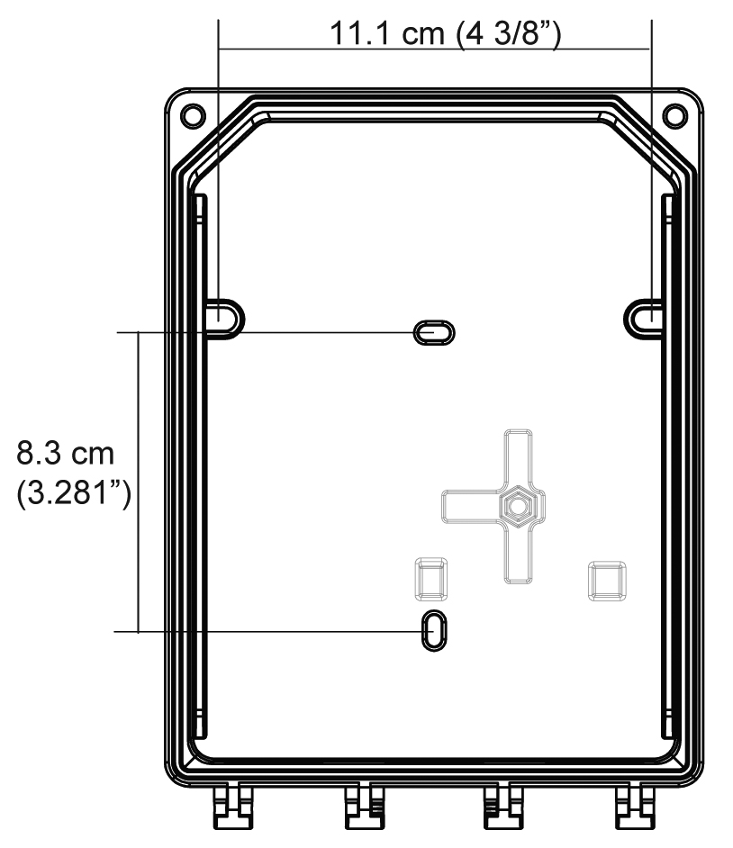
Figure 1. Unit Dimensions

- Pre-drill mounting holes from the back of the unit as needed.
- Securely mount the unit using the appropriate screws and anchors. The unit is designed to use #6 screws. Tighten to 8.7 in-lb (1 Nm) maximum.
- Close the unit cover and tighten screws to 29.7 in-lb (3 Nm).
- Do not remove PC board when removing knockouts.
- Knockout on back is not for conduit entry.

General Mounting Considerations:
- Must be easily accessible for calibration and maintenance.
- Mount the sensor close to the potential leak source for fastest possible leak detection.
- If personnel protection is the primary application, mount in the “breathing zone” (1–1.5m from the ground, within the range of a person’s respiration area).
- Protect the sensor from water, excessive humidity, and washdown.
- Take air movement and ventilation patterns into account.
- To prevent electrical interference, keep sensor and wire runs away from mercury vapor lights, variable speed drives, and radio repeaters.
- Protect the sensor from physical damage (fork lifts, etc.).
- Do not mount the sensor over a door in a refrigerated area.
- For highly critical locations, more than one sensor should be installed in each room.

Very Important:
- Never mount the sensor flat on a ceiling.
- Never mount the sensor on a vibrating surface.

Duct Mounting
Special Duct Mount Installation
This option works best for airflows between 500–4000 ft./min. The E3Point must be duct mounted using the custom box
provided with the duct mount version. All of the components housed within the box are factory assembled.
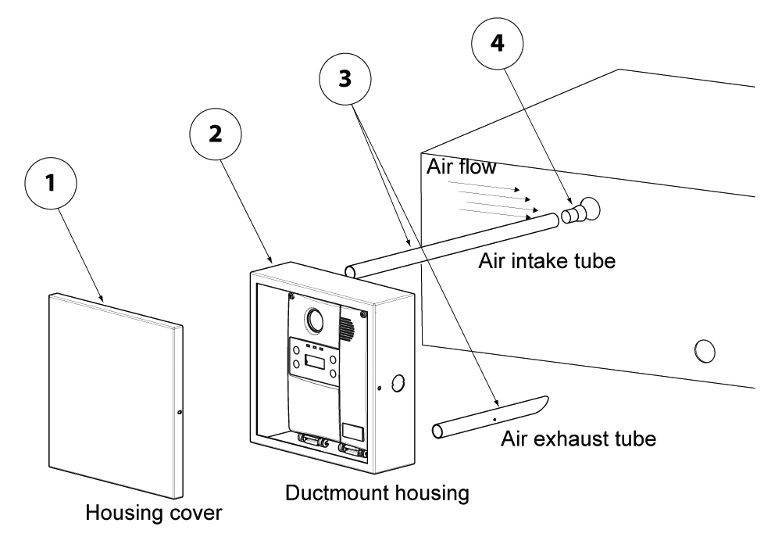
Figure 2. Duct Mounting

1. Select the location for the unit.
2. Measure and mark the holes for intake and exhaust tubes.
3. Drill the holes for the sampling tubes (making sure holes are large enough for plug).
4. Affix intake and exhaust tubes to the mounting box.
5. Insert the tubes into the holes on the ducting.
6. Screw the mounting box onto the duct.
7. Remove the desired knock out (depending on where cables will enter box) and affix appropriate conduit.
8. Run wiring through the conduit and duct mount box to the unit. Connect wires according to the Wiring Details.
9. Screw cover onto the E3Point and replace the cover on the mounting box.

Ensure to orient the air holes on the air intake tube to face the airflow.

Wiring
Guidelines
Electrical wiring must comply with all applicable codes. Operating conditions and site equipment that may be involved should be discussed with local operating personnel to determine if any special needs should be considered.

Ground the shield at the main control panel. Connect the shield wire in the sensor terminal block labeled shield. Tape all exposed shield wire at the sensor to insulate it from the enclosure.

Electrical Power: 24 VDC/VAC nominal, 0.35 amp maximum. Either AC or DC may be connected to the terminal block.

Output: Circuit board mounted sensor provides a linear 4-20 mA output. Monitoring equipment may have a maximum impedance of 500 ohms.

Wire: Signal wiring should be done with #20-24 AWG shielded twisted pair cable Belden 9841 or similar. Network units should have no more than 2,000 ft (600 m) of #22 AWG wire. Smaller gauge sizes are limited by the same resistance limit.

Power wiring should be sized by local codes, but never less than #20 AWG. 120 VAC wiring should be #14 or #12 AWG.

Wiring Diagrams
Circuit Board Connections
- Connect the power wiring to terminal J1
- Connect Communication wiring to terminal J2
- Connect external device (ventilator, strobe, etc.) to relay terminals J5, J6

3-Wire Current Sink Output 4-Wire Current Source Output
(VDC only)
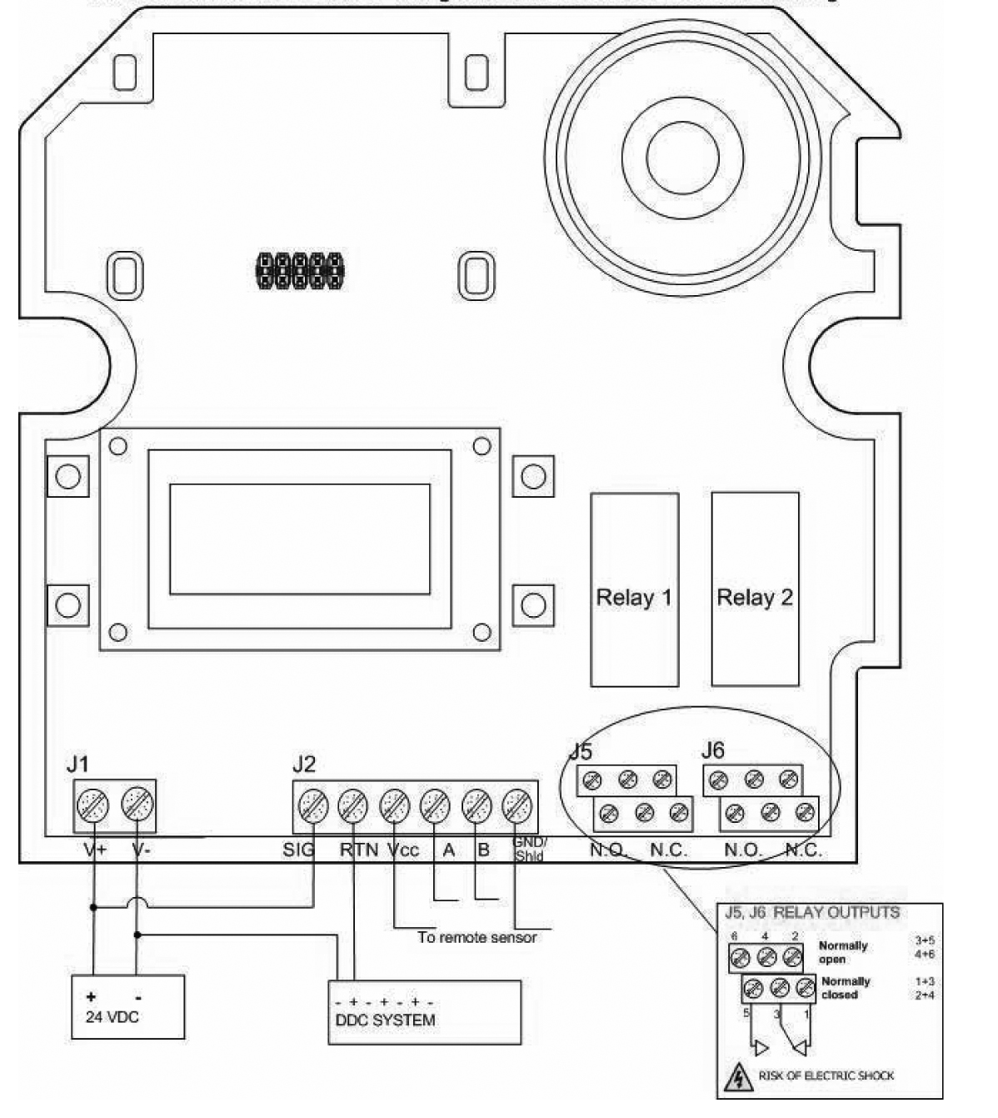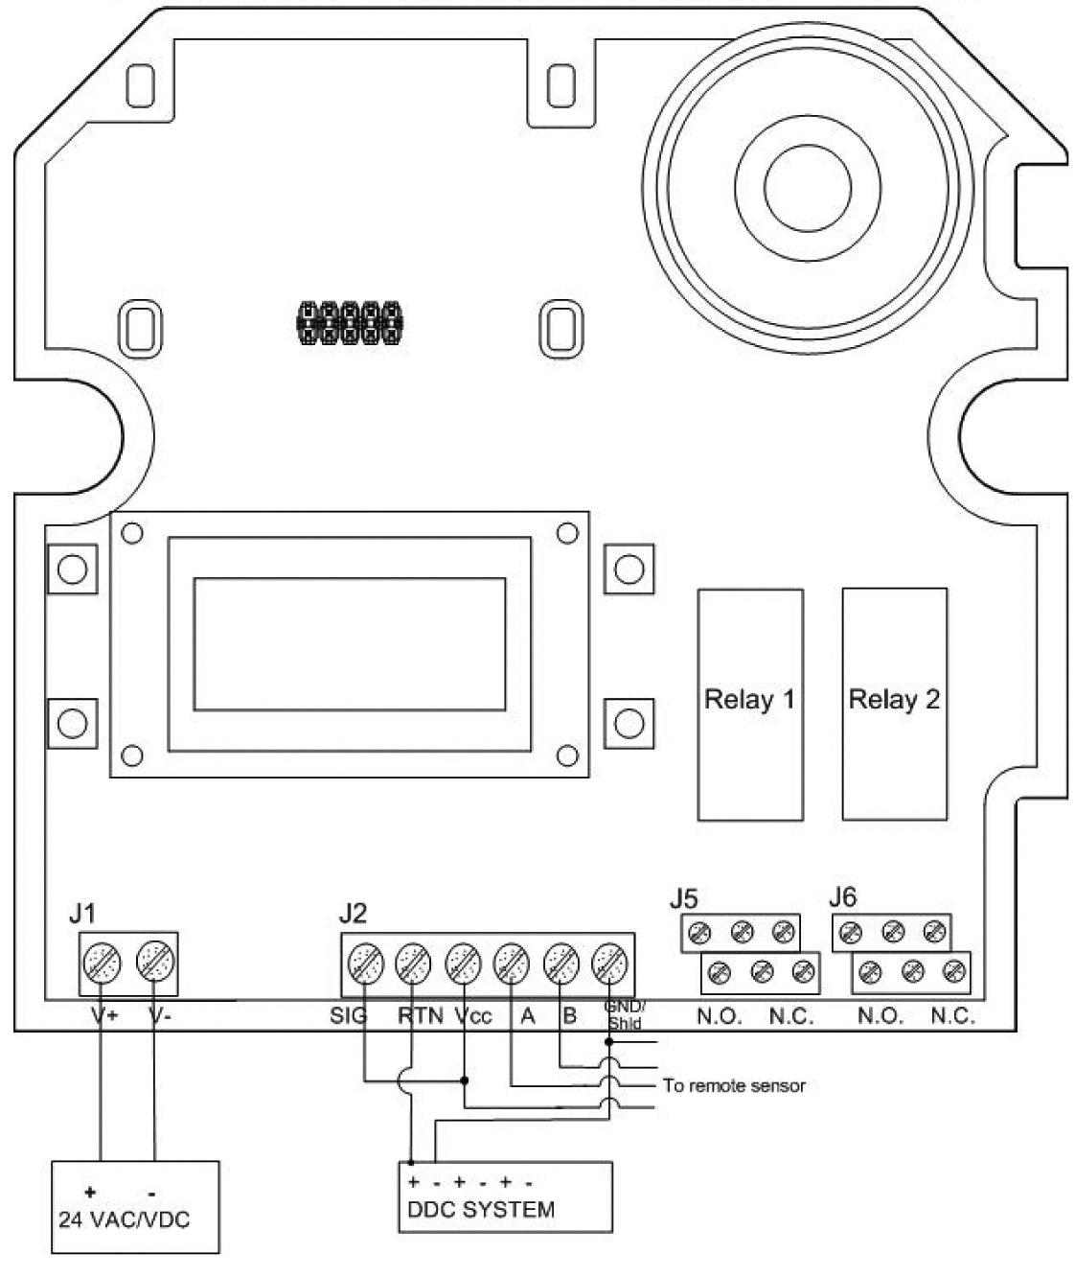

Figure 3. 3-Wire Current Sink Output Figure 4. 4-Wire Current Source Output

4-Wire Current Sink Output
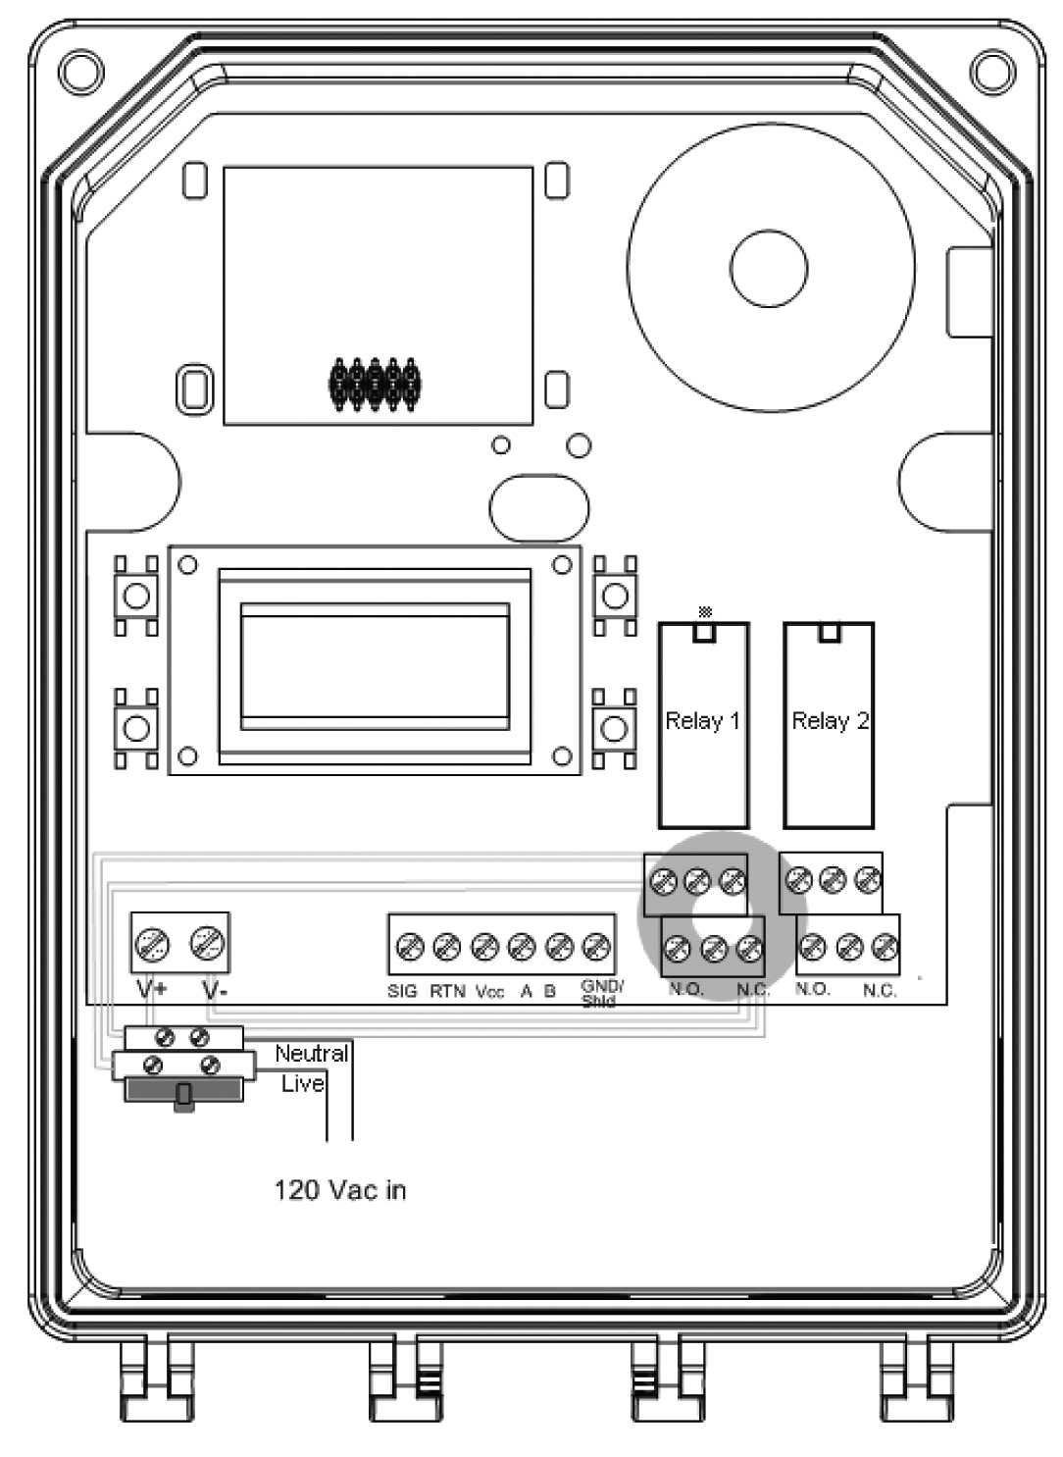
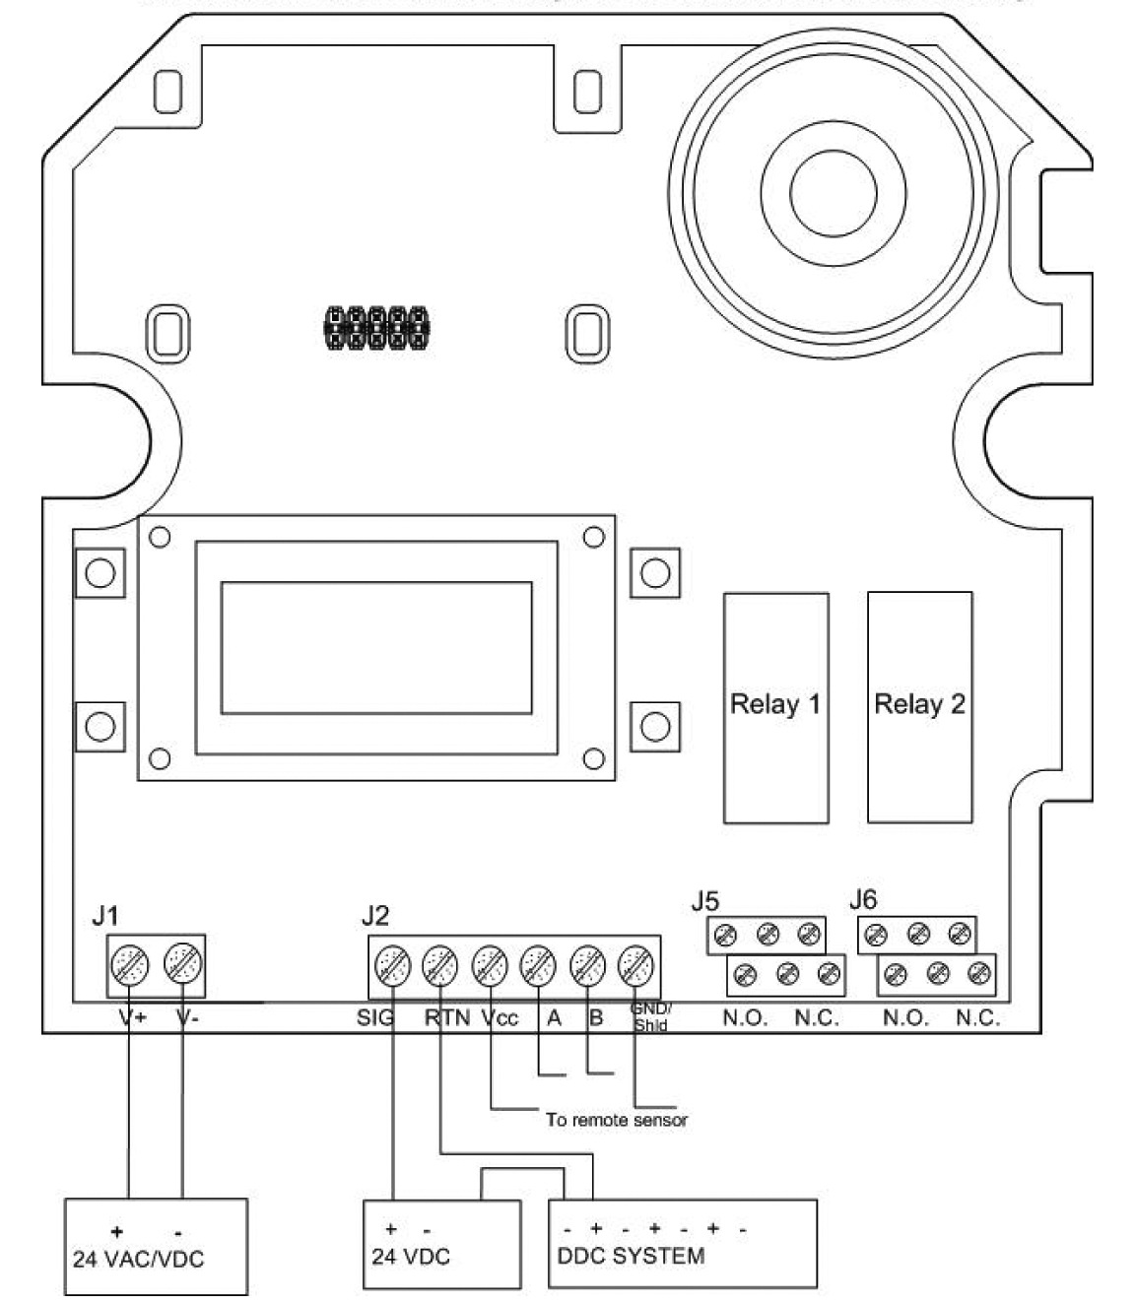
120 VAC Connection
The transformer is mounted under the PCB and connections to the power terminal are factory wired. Connect the live and neutral wires, as shown (ensure that power is off before attempting to connect the wires). Replace fuse with same type: 1A 250 VAC, T.

Figure 6. 120 VAC Connection

Figure 6. 120 VAC Connection

Figure 5. 4-Wire Current Sink Output

